# Winnable Games

We will take a look at some 1 and 2 player games and try to decide if you can win them and what strategy you should use if you can win.

|  |  |
| --- | --- |
| Team | Date |
|  |  |
| Team Roles | Team Member |
| Recorder: records all answers & questions |  |
| Speaker 1: reports answers and questions |  |
| Speaker 2: (for 3 person teams) reports answers and questions ...alternate with speaker 1 |  |

## Four-Puzzle

The four puzzle game is a square with 4 slots and 3 tiles numbered 1,2,3 and one empty space.  
Allowable moves slide a tile to the empty space from any other space, including a diagonal move.

1. How can you get from the start state below to the end state?  
     
   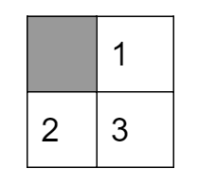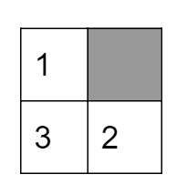



1. How many possible states are there?

1. Can you draw a diagram of game states with arrows between states one move apart? You don’t need to do all the states...just 4 or 5….
2. If the second state from problem 1 is the winning state, how could a computer rank the other possible states?
3. How could a computer decide what moves to make to try to win?
4. If diagonal moves are not allowed, what is the answer to problem 1?

## NIM

Rules: start with 21 pennies in the center. Each player must take 1-4 pennies each turn. The player to take the last penny loses. Play with these rules until you think you see a strategy to winning. If you need help ask one of the instructors for a hint.

1. What is your strategy for winning?
2. Does starting with 18 pennies in the middle change anything about your strategy?
3. Can 1 player win each time, if so what do they do and do they go first or second?
4. Which player would you want to be if the game used 1482 pennies?